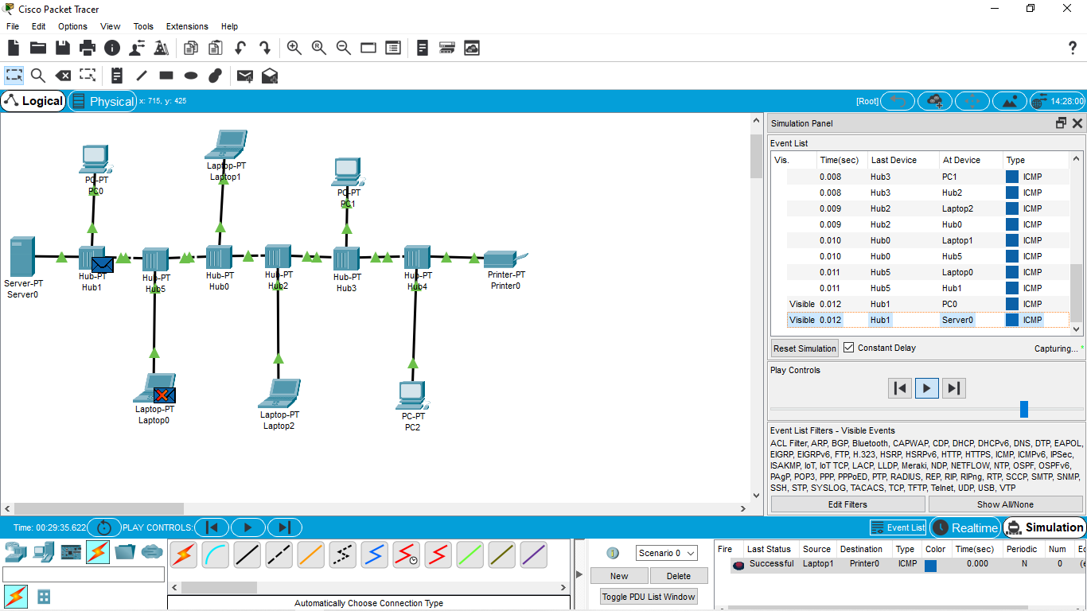

***Data Link Layer Traffic Simulation using Packet Tracer Analysis of CSMA/CD& CSMA/CA***